**JDBC STEPS TO STORE DATA PERMANENTLY**

**In this First step we created a class jdbc in which I demonstated how to create a connection with JDBC**

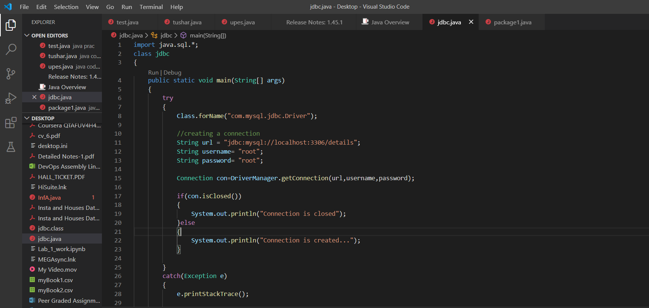

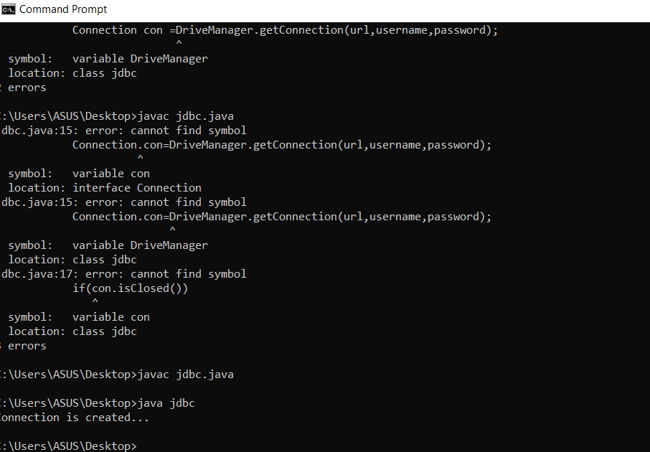

After that we created a class known as jdbc data which will have connection with our database and created a table in it

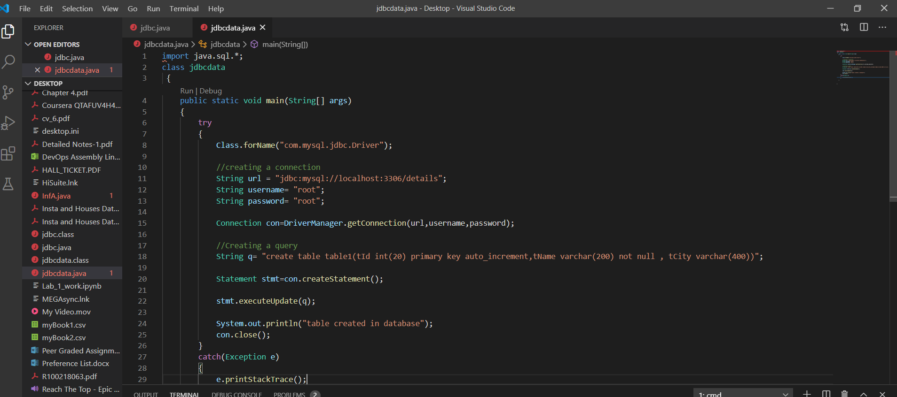

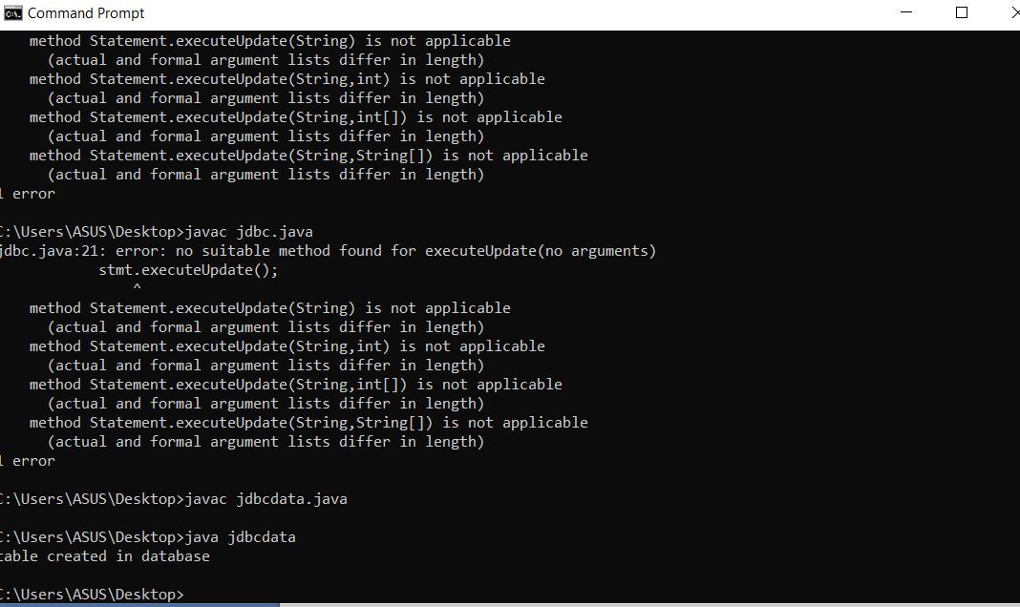

For Confirmation of table we signed itno MySQL to check whether the table is created or not.

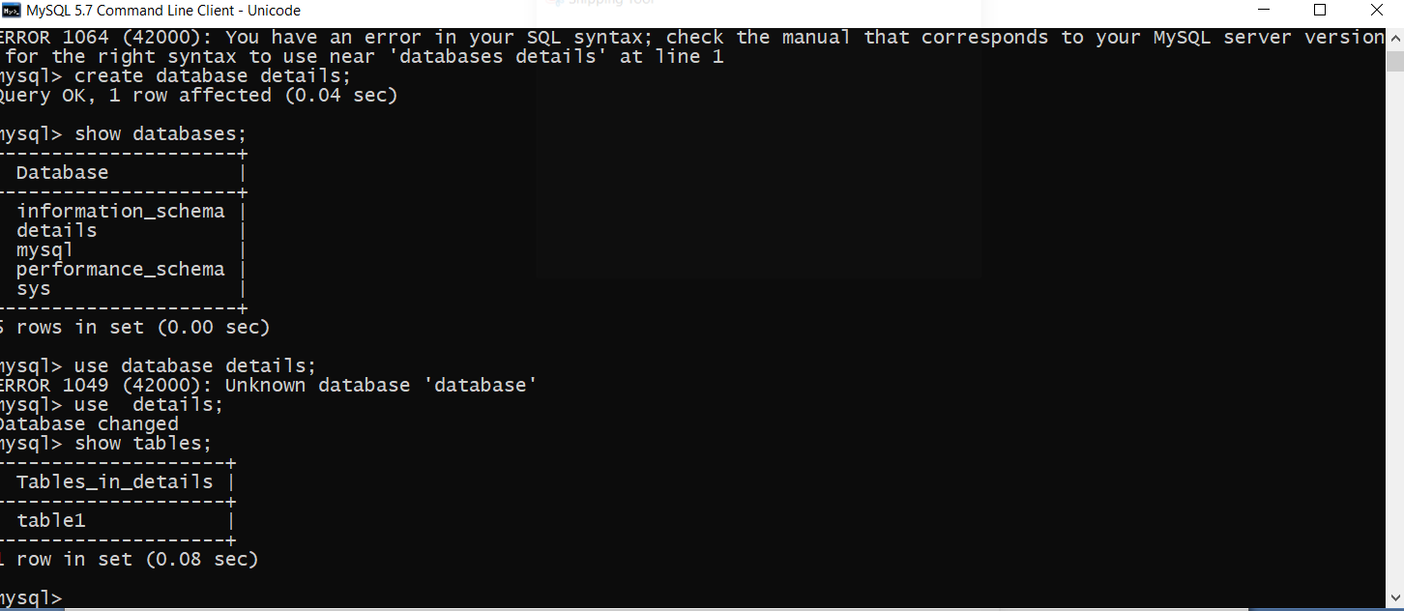

Then after checking the table we created a different class known as jdbcdetails in which we entered the data which will get saved in the database.

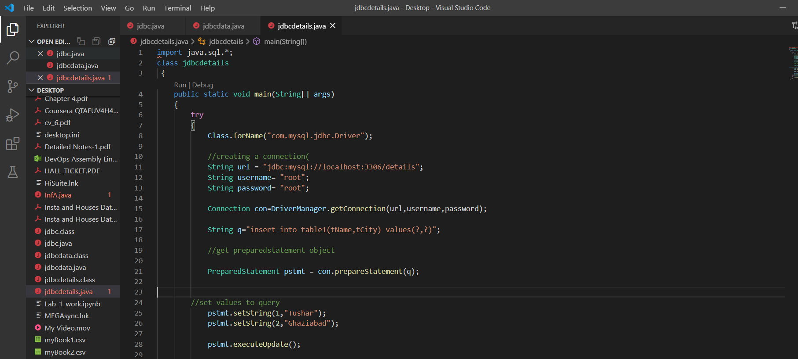

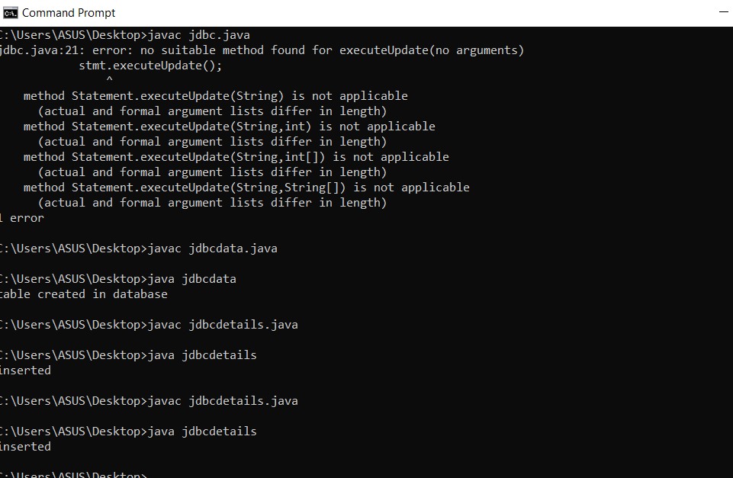

Here is the output of MySQL which shows about the data filled in the table